# Generative AI Lab Record

## Experiment Title

Prompt Engineering, AI Image Generation, and AI Video Creation

## Objective

To understand structured prompt design, generate professional content using LLMs, create AI-based images using DALL·E, and convert text into videos using Fliki.ai and Kaleido.ai.

## Exercise 1: Workshop Launch Email (Launch Email Using Chatgpt)

Prompt:  
Act as a professional academic coordinator. Draft a formal launch email for a one-day workshop on 'Generative AI Tools and Applications' for undergraduate engineering students. Include workshop objective, date, time, mode, key topics, registration details, and contact information. Tone: Professional and motivating. Word limit: 180–200 words.

**Output:**

**Subject: Launch of One-Day Workshop on Generative AI Tools and Applications**

**Dear Students,**

**The Department of Computer Science and Engineering is pleased to announce a one-day workshop titled “Generative AI Tools and Applications”, designed to provide practical exposure to cutting-edge AI technologies transforming modern industries.**

**The objective of this workshop is to help undergraduate engineering students understand the fundamentals of generative artificial intelligence and gain hands-on experience with popular AI tools used for content creation, automation, and intelligent decision-making.**

**Workshop Details:**

* **Date: 13 January 2026**
* **Time: 10:00 AM**
* **Mode: Online**

**Key Topics Covered:**

* **Introduction to Generative AI and Large Language Models**
* **Prompt engineering for effective AI outputs**
* **AI-powered image and video generation tools**
* **Real-world applications across engineering domains**

**Interested students are required to register in advance using the registration link shared by the department. Participation certificates will be issued to all registered students who attend the full session.**

**For further information or queries, please contact the workshop coordinator at 6363543795.**

**We strongly encourage enthusiastic students to take advantage of this learning opportunity and enhance their AI skill set.**

**Warm regards,  
Rishik Vihaan  
Academic Coordinator  
Department of Computer Science and Engineering  
RV University**

## Exercise 2: DALL·E Image Generation (using DALL·E)

Prompt:  
Create a professional digital poster for a university-level workshop on 'Generative AI and Future Technologies'. Include AI-themed visuals, students working on laptops, a modern classroom environment, an orange and white color theme, and a high-resolution poster-style design.

**Output:**

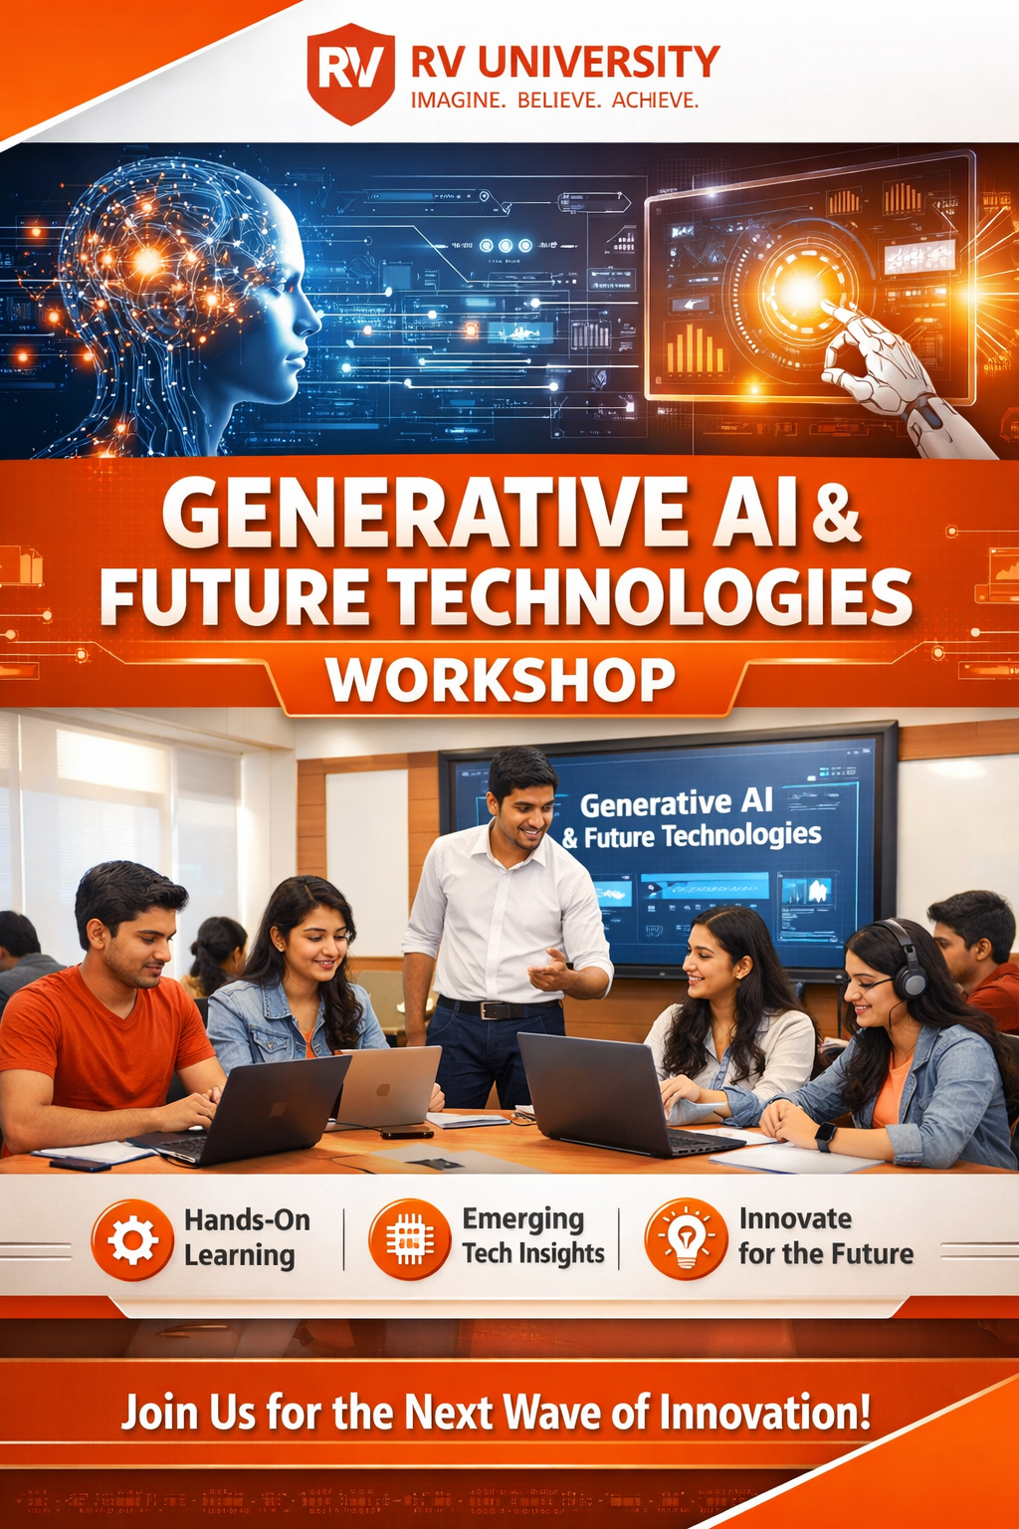

## Exercise 3: AI Video Creation (Fliki.ai )

Prompt:  
Create a 30-second promotional video for a university-level workshop titled 'Generative AI Tools and Applications'. Highlight objectives, key topics, and registration details. Tone should be professional and motivating. Use short, clear sentences and a logical flow.

**Output:**

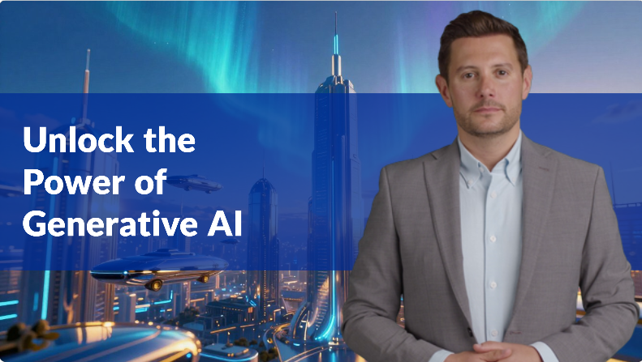

## Exercise 3: AI Image Creation (Kalaido.ai )

**Kalaido.ai Prompt Used:**

Create a **high-resolution academic poster image** for a **university-level workshop** titled  
**“Generative AI Tools and Applications.”**

**Include the following visual elements:**

* AI-themed illustrations (neural networks, digital brains, futuristic interfaces)
* Engineering students working on laptops
* Modern university classroom environment
* Orange and white color theme
* Clean, professional, poster-style layout suitable for academic promotion

**Image Style Constraints:**

* Realistic yet futuristic design
* Balanced composition with clear focus
* High clarity and sharp details
* Professional academic aesthetic

**Output:**



## Conclusion

This lab exercise demonstrated the importance of prompt structure in generating high-quality text, images, and videos using Generative AI tools.